the modify statement is like a combination of the insert statement and the update statements.

You can use it to either insert a brand-new record, or modify an existing one.

But in general, you want to use the insert and update statements where you can.

sometimes you will be writing code, that either has to insert or update a record, depending on certain situations. And the modify statement is fine to use in that regard.

So, let's have a look now what the modify statement looks like



a simple modify zemployees, this will use the header record of the internal table.

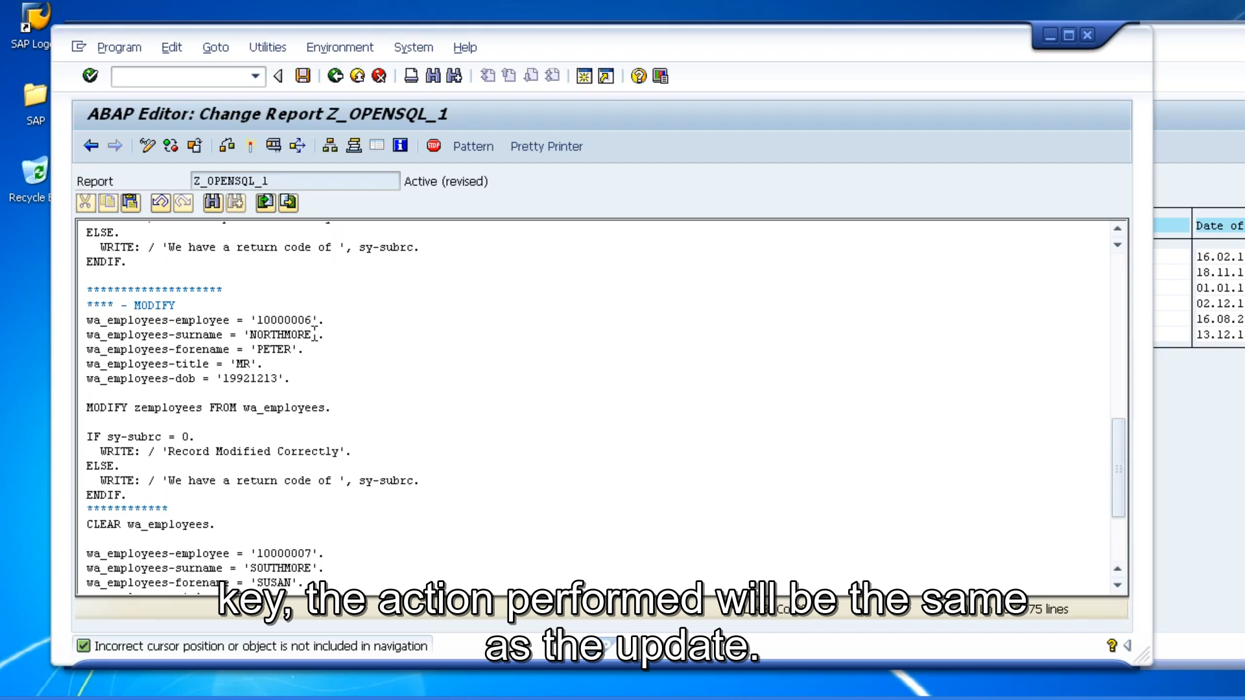

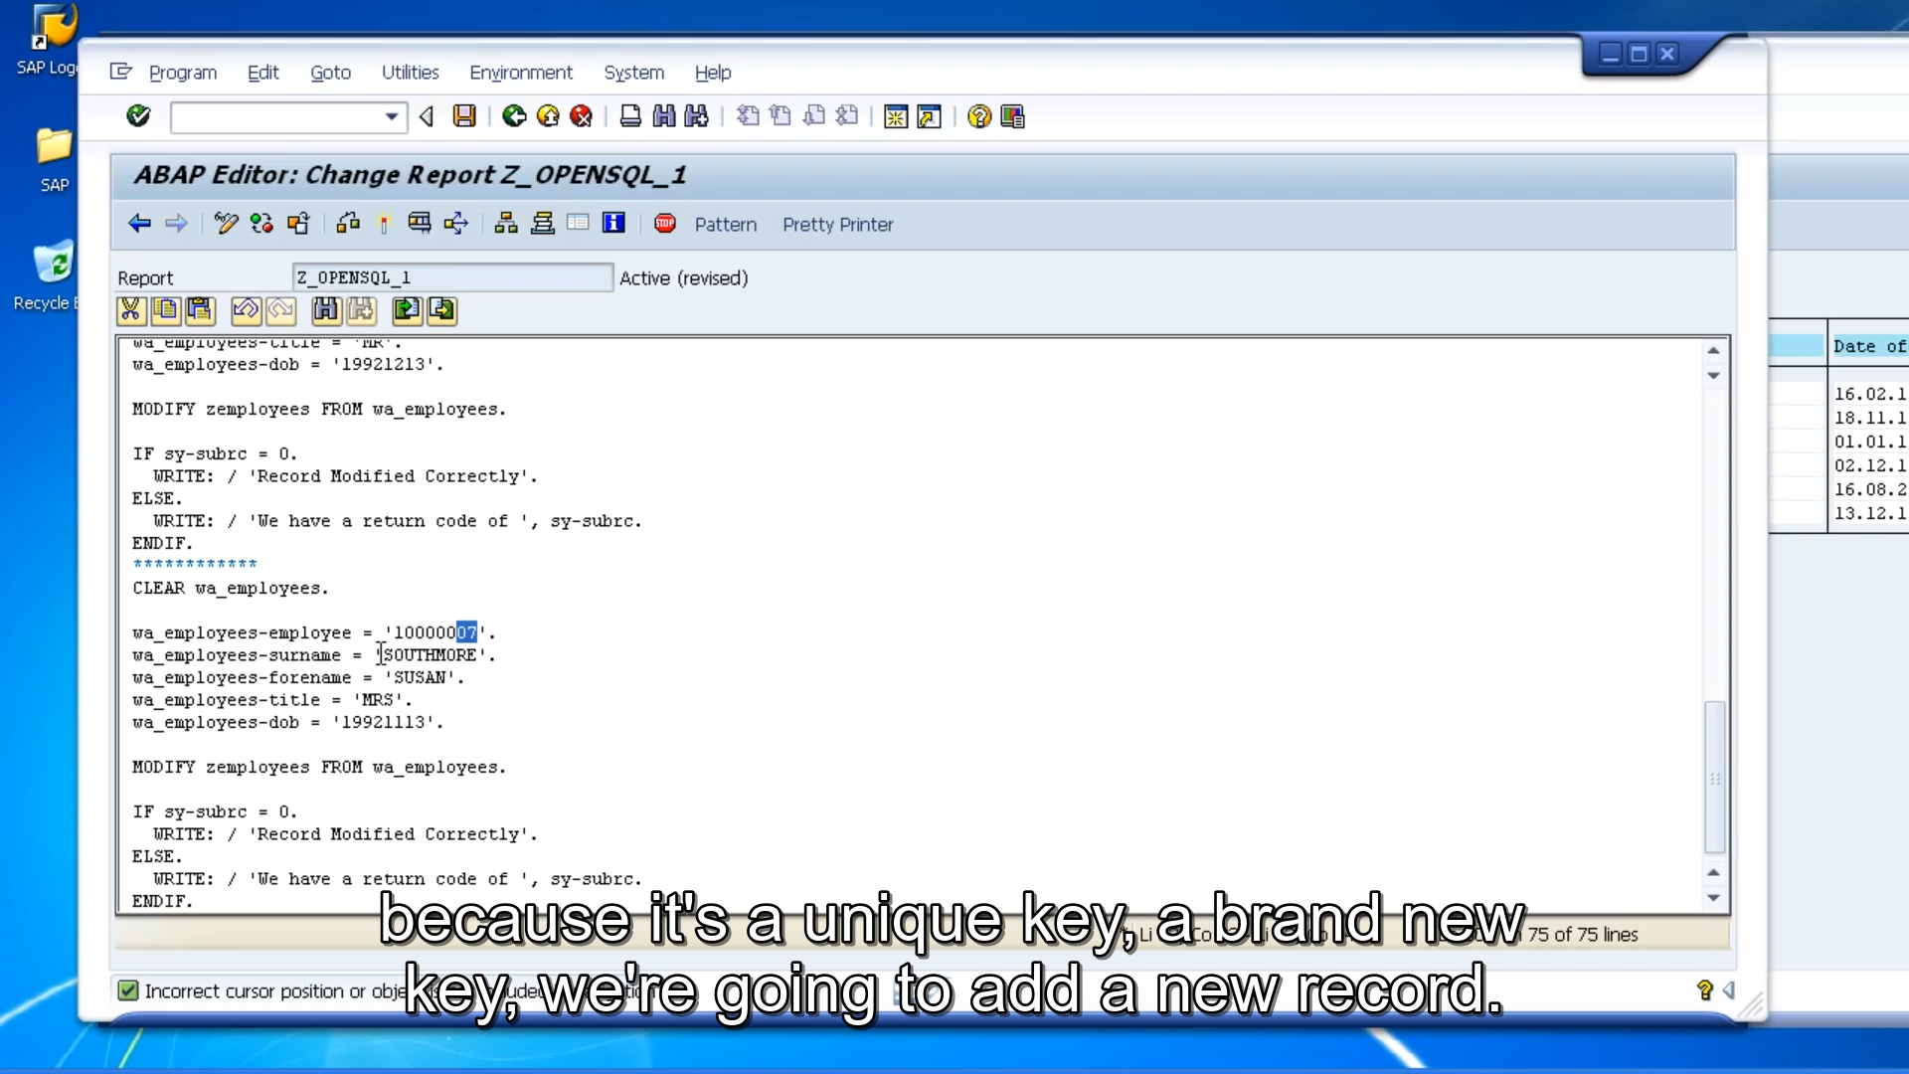

But we do not want that. We want to use the work area. So, - Our modified statement looks very similar to the others where we will modify our table, then employees from our work area. Now when the modified statement is executed, the primary key fields from your work area, will be checked against those records held in the table. If a record exists, that record will be updated with the content held in your work area. If the record doesn't exist, then a new record will be inserted at the end of the table. And that's with the other statements, if a modified statement is unable to execute either of these two tasks, the SY-SUBRC field, will return with a value of 4, but if it's a successful, it will contain a value of 0.